H.T No
Regulations:
A22

Sreenidhi Institute of Science and Technology
(An Autonomous Institution)
Code No:9B201 Date: 09-August-2024 (FN)

B.Tech I-Year II- Semester External Examination, August-2024 (Regular & Supplementary)
ENGINEERING MECHANICS (MECHANICAL)

Time: 3 Hours Max.Marks:60

Note: a) No additional answer sheets will be provided.
b) All sub-parts of a question must be answered at one place only, otherwise it will not be valued.
c) Missing data can be assumed suitably.
Bloom's Cognitive Levels of Learning (BCLL)

Remember | L1 | Apply | L3 | Evaluate | L5
Understand | L2 | Analyze | L4 | Create | L6

Part - A Max.Marks: 6x2=12

Answer all QUESTIONS, EACH QUESTION CARRIES 2 MARKS.

 |  | BCLL | CO(s) | Marks
1 | What are the different types of Beams? | L1 | CO1 | [2M]
2 | Define Limiting Force of Friction. | L1 | CO2 | [2M]
3 | Distinguish between centroid and centre of gravity. | L1 | CO3 | [2M]
4 | State parallel axis theorem | L1 | CO4 | [2M]
5 | Define translation. | L1 | CO5 | [2M]
6 | State work energy equation.. | L1 | CO6 | [2M]

Part – B Max.Marks: 6x8=48
ANSWER ALL QUESTIONS. EACH QUESTION CARRIES 8 MARKS.

 |  | BCLL | CO(s) | Marks
7. | A system of connected flexible cable shown in Fig.3 is supporting two vertical forces 200 N and 250 N at points B and D. Determine the forces in various segments of the cable. [10 M]  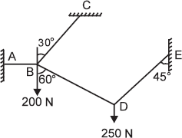 | L4 | CO1 | [8M]
 | OR
8 | a) Explain free body diagram with example. [5 M]  b) State and prove Lami’s theorem. | L2 | CO1 | [8M]
9. | State laws of friction and explain with suitable examples. | L2 | CO2 | [8M]
 | OR
10 | A king post truss of 8 m span is loaded as shown in Figure. Find the forces in each member of the truss and tabulate the results  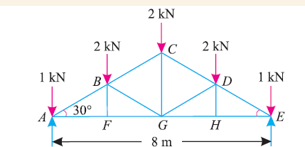 | L4 | CO2 | [8M]
11 | A semicircle of 90 mm radius is cut out from a trapezium as shown in Figure. Find the position of the Centre of gravity of the figure.  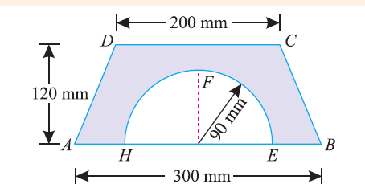 | L4 | CO3 | [8M]
 | OR
12 | State and prove pappu's theorems. | L4 | CO3 | [8M]
13 | Determine the mass moment of inertia of a slender rod of length L mass M about centroidal axis perpendicular to axis of the rod. | L4 | CO4 | [8M]
 | OR
14 | An I-section is made up of three rectangles as shown in Figure Find the moment of inertia of the section about the horizontal axis passing through the center of gravity of the section.  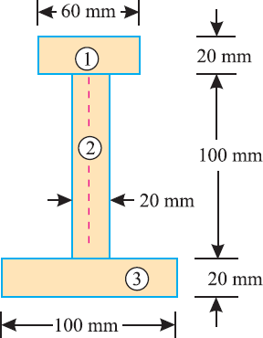 | L2 | CO4 | [8M]
15 | Derive the expression for the trajectory of a particle thrown at angle Ɵ with the horizontal and list out the assumptions | L3 | CO5 | [8M]
 | OR
16 | Referring to Fig assume A weigh 900 N B weighs 300N. Determine the acceleration of the bodies if the coefficient of kinetic friction is 0.1 between the cable and the fixed drum.  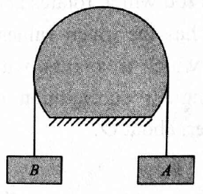 | L4 | CO5 | [8M]
17. | 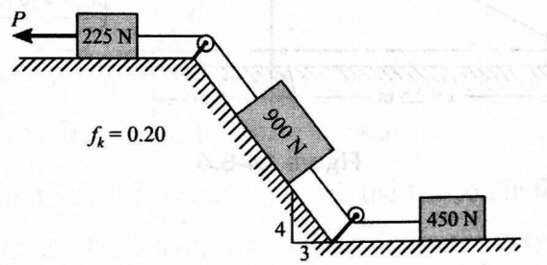  Determine the constant force P that will give the system of bodies shown in Fig a velocity of 3 m/s after moving 4.6 m from rest. | L3 | CO6 | [8M]
 | OR
18 | 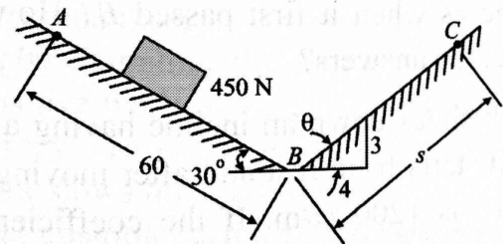  As shown in Fig. a 450 N body moves along the two inclines for which the coefficient of friction is 0.2. If the body starts from rest at A and slides 60 m down the 30º incline, how far will it then move along the other incline? What will be its velocity when it returns to B? | L3 | CO6 | [8M]
-- 00 -- 00 –

